Q,1, 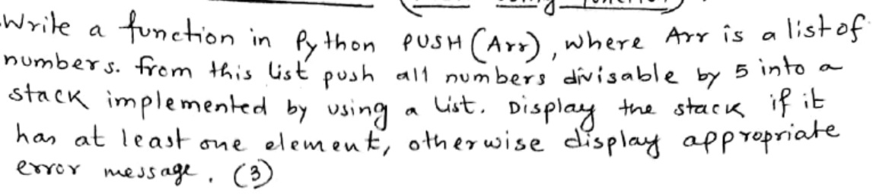

Fill in the blanks :

def PUSH(Arr):

s=___________#1 to create a stack

for i in range(0,len(Arr)):

if _______________: # 2 condition that checks number of list Arr divisible by 5

s.__________________ # 3 function to push data from Arr list into stack

if __________: # 4 condition that specify stack is empty

print("stack is empty")

else:

print("the stack is: ",s)

L=[17,15,27,30,47,45]

___________#5 function call

Q,2, 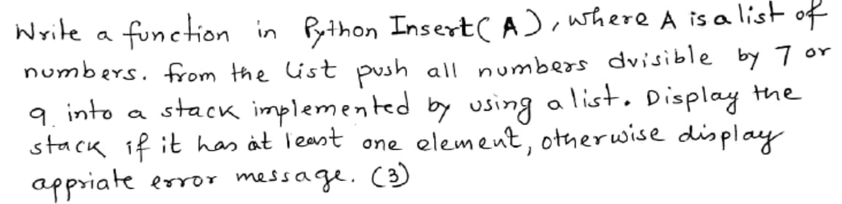

Fill in the blanks :

def Insert(A):

s=___________#1 function to create stack

for i in range(0,len(A)):

if _____________: # 2 condition that checks number of list Arr divisible by 7 or 9

s._____________# 3 function to push data from list A into stack

if __________: # 4 condition to specify stack is empty

print("stack is empty")

else:

print("the stack is: ",s)

L=[45,27,14,55,63,81,71,34]

_______ # 5 call the function

Q,3,

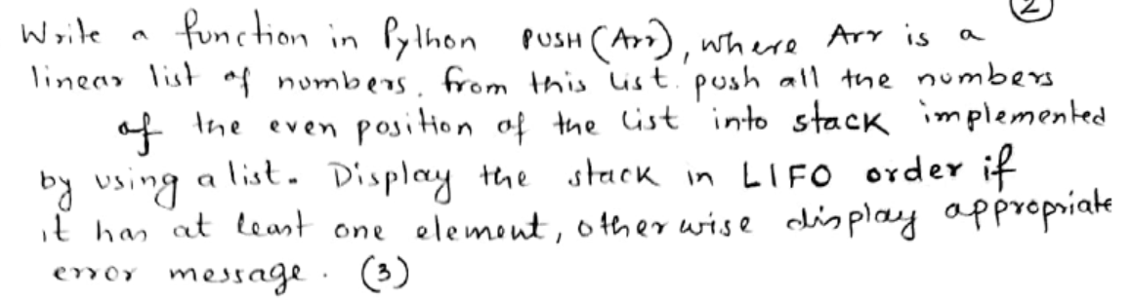

Fill in the blanks :

def push(Arr):

s=_______ # 1 to create stack

for i in range(0,len(Arr)):

if __________: # 2 condition to test even position in the list Arr

s.____________ # 3 to push data of even position from Arr into stack

if ____________: # 4 condition that specifies the stack is empty

print("stack is empty")

else:

for i in range(___________): # 5 set range to traverse reverse order into stack

print(s[i]) #

L=[45,27,14,55,63,81,71,34]

push(L)

Q,4,

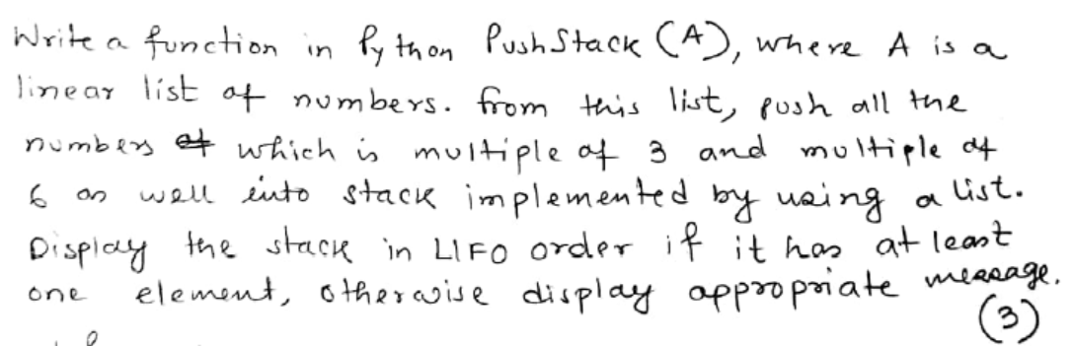

def PushStack(A):

s=_______ # 1 to create stack

for i in range(0,len(A)):

if _____________: # 2 condition that checks number of list Arr multiple of 6 or 3

s.___________# 3 push each element from Arr list into stack

if __________: 4 condition that satisfy stack is empty

print("stack is empty")

else:

for i in range(___________):#5 set range to traverse reverse order into stack

print(s[i])

L=[45,27,14,55,63,81,71,34]

PushStack(L)

Q,5,

def push(Country,N):

Country.________(len(Country),N #1 to push data into stack

Country=______ #2 to create stack

C=['India','USA','UK','Canada','Sri Lanka']

for i in range(0,len(C),_____): #3 to insert alternate element from Country list

__________# 4 call the push() function

print(Country)

Q,6,

def push(Student,N):

Student._________(len(Student),N) #1 function to insert data into stack

Student=______#2 to create stack

S=['John','David','Arnold','Albert','Mathews']

for i in range(_____,len(S),______): #3 to insert odd position element from Country list

________ #4 call push() function

print(Student)